**APPLICATIONS OF ML**

**EXP 1**

NAME : Rohan Nyati

ROLL NO : R177219148

SAP ID : 500075940

NAME : Rajneesh

ROLL NO : R177219143

SAP ID : 500076347

NAME : Shantanu Jaswal

ROLL NO : R177219170

SAP ID : 500075224

**NUMPY :**

Numpy means numerical python , it is a library of the python programming language

**I**f you want to perform any array based or matrix based calculation and data analysis then we use numpy library , numpy can carry out complex problems with ease. Like in other programming language if you want to multiply two different array or matrices then you have to create loops but such is not the case in it , you can just perform any arithmetic operation like any other scalar identity

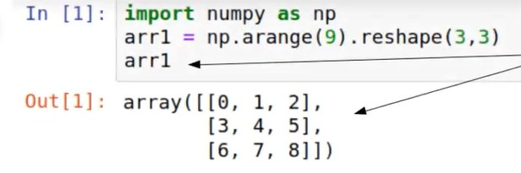

Similarly we can perform any element wise operation without using any loop

Numpy employs “Contiguous Memory”. A list stores the data at “random” memory blocks (i.e not grouped together), which leads to more time consumption. Whereas Numpy uses contiguous memory to group all the data in closely grouped block, leading to faster/effective cache utilization

Numpy is used in many places such as to manipulate graphs and plot graphs . It is also utilized with pandas for quicker computation and as MATLAB replacement .

We import numpy in a notebook as

Import numpy as np

**PANDAS:**

Pandas is a python library which is considered the best for exploratory data analysis. Python stands for python for data analysis , it is the most important tool for data manipulation and cleaning , it can perform things very fast and easily It has some data manipulation operations such as merging, reshaping, data cleaning, and data wrangling.

Pandas are used in many places such as:

1. Arbitrary matrix data with row and column labels.
2. Tabular data like in SQL table or Excel spreadsheet.
3. Observational/statistical datasets.

Similar to NumPy, Pandas is **one of the most widely used python libraries in data science**. It provides high-performance, easy to use structures and data analysis tools. Unlike the NumPy library which provides objects for multi-dimensional arrays, Pandas provides an in-memory 2d table object called Dataframe.

In a nutshell, Pandas is a **useful library in data analysis**. It can be used to perform data manipulation and analysis. Pandas provide powerful and easy-to-use data structures, as well as the means to quickly perform operations on these structures.

Just like numpy we import pandas as

Import pandas as pd

Pandas has two ways of data analysing

1. SERIES
2. DATAFRAME

SIMILARITY BETWEEN PANDAS AND NUMPY

1. Pandas adopted coding style from numpy
2. Pandas also gives the preference for data processing without loops

DIFFERENCE BETWEEN PANDAS AND NUMPY

1. Numpy works with arrays while pandas work with dataframe and series
2. Numpy is best suited for working with same kind of data while pandas is suited for tabular or heterogenous form of data
3. You have to import numpy as np while pandas as pd